Data Visualization Lab Report
Name: Mithil S
Roll No.: 240968160
Section: PH-77
Lab: Data Visualization Lab
Date: April 8, 2025

Title: Analysis and Visualization of the Digimon Dataset

Objective of the Analysis
This analysis aims to extract actionable insights from the Digimon datasets to support players in building the most powerful and efficient teams. By leveraging data on Digimon statistics, moves, and support skills, we provide evidence-based strategy recommendations to enhance team composition and in-game performance.

Data Exploration Summary
We explored three datasets: digimon_df, move_df, and supported. Below are the insights obtained through initial examination and value counts.

🧬 Digimon List
- Total Digimon: 249
- Attributes Analysed: HP, SP, Atk, Def, Int, Spd at level 50
- Memory Usage: Most common values: 12 (35 Digimon), 18 (33), 8 (29)
- Equip Slots:
  - 1 Slot: 112 Digimon
  - 2 Slots: 77
  - 3 Slots: 42
  - 0 Slots: 18

⚔️ Stat Summary (at Level 50)
Stat | Mean | Min | Max
HP | 1210 | 530 | 2080
SP | 110 | 50 | 203
Atk | 125 | 52 | 318
Def | 116 | 59 | 213
Int | 113 | 50 | 233
Spd | 120 | 61 | 218

🧬 Digimon Categories
- Stages: Mega (74), Ultimate (58), Champion (54), Rookie (38)
- Types: Virus (82), Vaccine (70), Data (60), Free (37)
- Attributes: Dark (37), Fire (33), Light (29), Neutral (28), Plant/Electric (25 each), Earth/Water/Wind (24 each)

🌀 Move List
- Total Moves: 387
- Attributes: SP Cost, Power, Type, Attribute, Inheritable

🔧 Move Stats Summary
Attribute | Mean | Min | Max
SP Cost | 14 | 0 | 60
Power | 60 | 0 | 250

🎯 Move Types
- Physical: 203
- Magic: 127
- Support: 49
- Fixed/Direct: 4 each

🔥 Move Attributes
- Most common: Neutral (102), Fire (58), Light (44), Dark (41)

🔁 Inheritable Moves
- No: 249
- Yes: 138

🧠 Support Skills List
- Total Skills: 86
- All entries are unique and complete.
- Example: Adroit Wisdom — Increases INT by 15%

✅ Key Observations
- The Digimon dataset is clean and includes diverse stat ranges and types.
- Move data is well-distributed, with most moves being either physical or magic.
- Support skills are all unique and serve a wide range of strategic purposes.
- Mega-stage Digimon are the most common, possibly suggesting late-game dominance.
- There's a slight imbalance in type and attribute distributions (e.g., more Virus types, Darker/Fire attributes).

2. Data Integration and Cleaning
In this phase, we prepared the Digimon datasets for analysis by merging related information and ensuring the data quality through systematic cleaning. This process is crucial to ensure the accuracy, consistency, and integrity of the insights generated in later stages.

🔗 2.1 Data Integration
We combined three primary datasets:
- digimon_df – Stats and attributes of 249 Digimon
- move_df – Details of 387 unique moves
- support_df – A list of 86 support skills
To unify the data:
- Merged the digimon_df and move_df datasets on the common Attribute column.
- Resolved mismatched attribute names (e.g., converted "Thunder" → "Electric") for consistency across datasets.
- Selected only the highest Power move per attribute using groupby() to avoid multiple repeated entries for each Digimon.
This ensured that each Digimon was paired with one optimal, high-impact move that aligns with its natural attribute type.
✅ Final merged dataset shape: (249, 19)

🧹 2.2 Data Cleaning

✅ Missing Values Check
Dataset | Missing Values
Digimon List | 0
Move List | 0
Support List | 0
All datasets are complete with no missing values.

🌀 Duplicate Rows
Dataset | Duplicates
Digimon List | 0
Move List | 0
Support List | 0
No duplicate rows detected.

⚙️ Other Cleaning Tasks
- Converted the Power column in move_df to numeric for analysis.
- Ensured correct data types for all numeric columns (HP, SP, Atk, Def, Int, Spd).
- Standardized categorical labels (e.g., fixed inconsistent spellings and capitalizations).
- Re-aligned column names post-merge to distinguish origin (Type_x from Digimon and Type_y from Moves).

Sample of Cleaned & Merged Dataset

🧾 Integration Summary
- ✅ Standardized all Attribute values for cross-dataset compatibility
- ✅ Merged datasets using common Attribute field
- ✅ Selected strongest move per Digimon based on attribute-alignment and power
- ✅ No missing or duplicate data remains in the final dataset
- ✅ Final dataset is clean, consistent, and ready for in-depth analysis

Data Analysis and Visualization of Digimon Dataset
This section presents tabulations and visualizations using Python libraries like Pandas, Matplotlib, and Seaborn to extract key insights from the cleaned and merged Digimon dataset.
The analysis contributes towards the understanding of team-building strategy and identifying powerful Digimon based on key metrics.

1. HP vs SP Scatter Plot
- Insight: There's no strong linear correlation between HP and SP at level 50.
- Interpretation: Digimon with high HP don't necessarily have high SP and vice versa. This suggests players may need to balance teams with dedicated tanks (high HP) and casters (high SP) instead of looking for all-rounders.
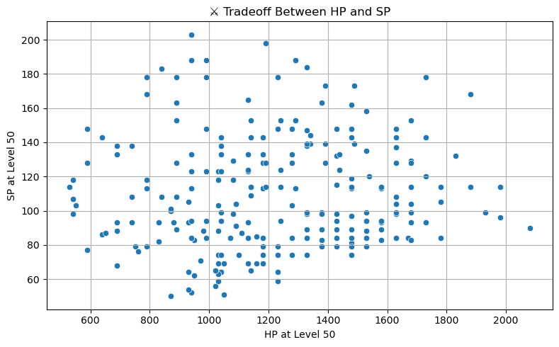

2. Digimon Type Distribution
- Most Common Type: Virus
- Least Common Type: Free
- Interpretation: The Virus type dominates the dataset, possibly implying more aggressive/attack-focused Digimon. This can influence team-building strategies depending on strength/weakness matchups.
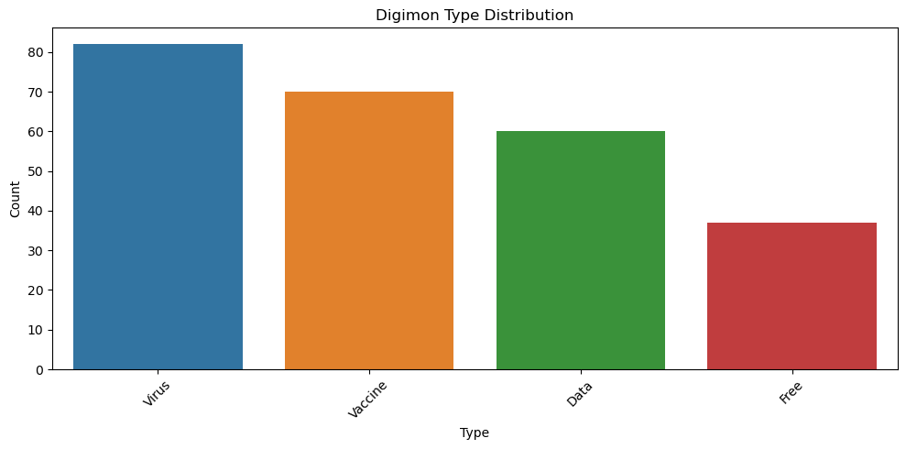

3. Stats by Evolution Stage (Box Plots)

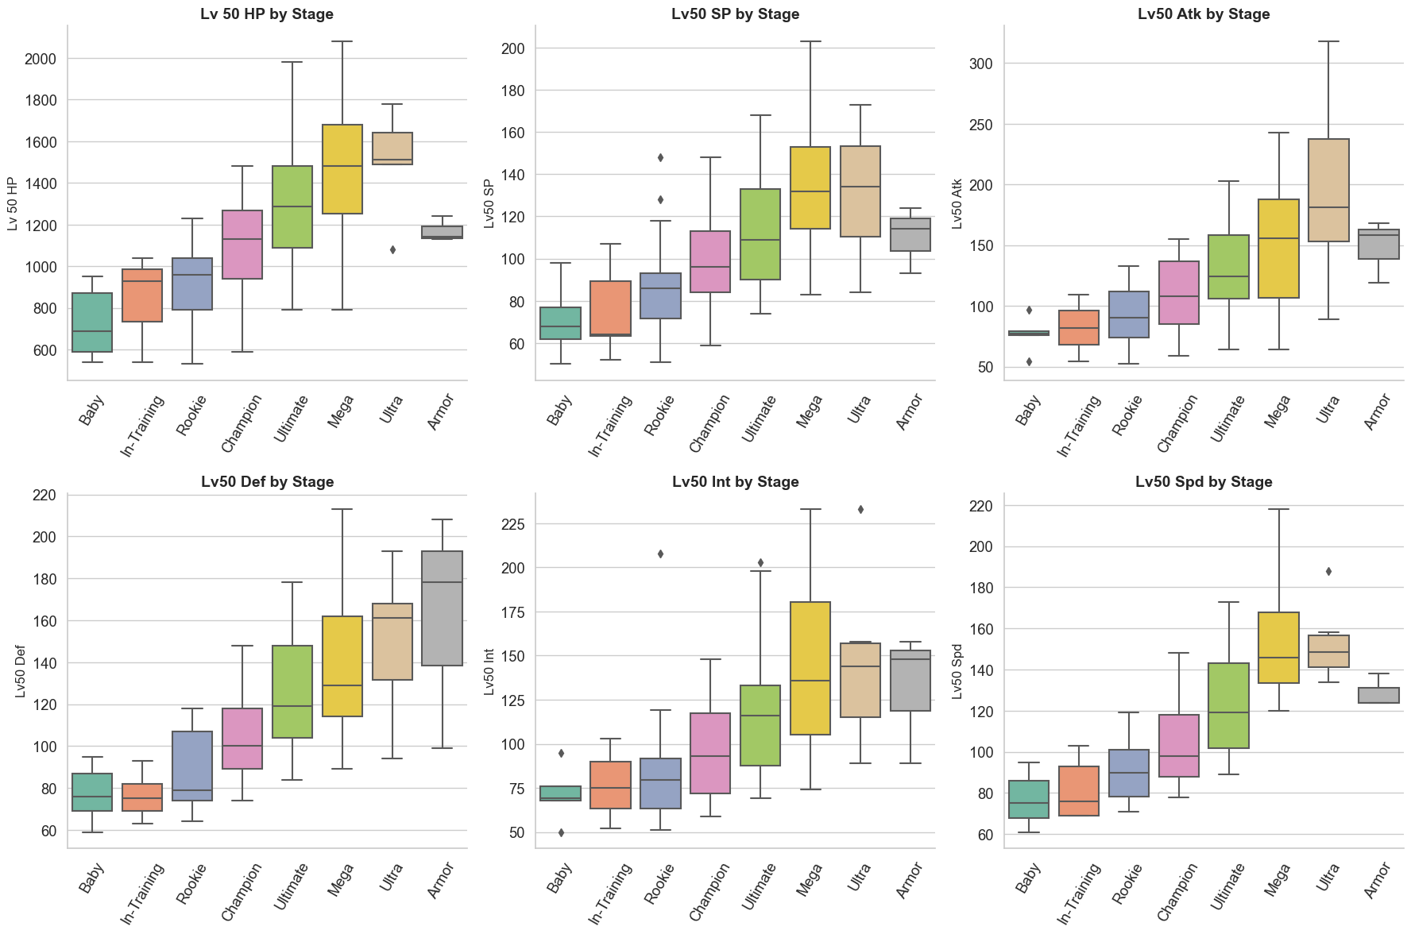
Across the six graphs showing stats by stage, a clear progression is visible:
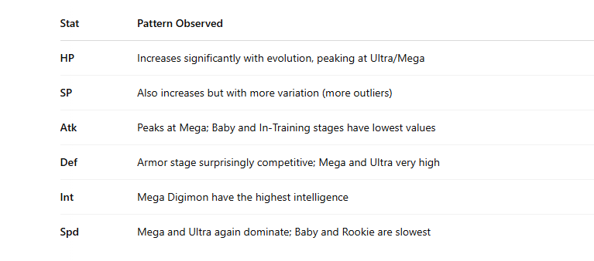

Correlation Heatmap
- Strongest Positive Correlation: SP ↔ INT (0.90)
- Moderate: HP ↔ ATK (0.61), SP ↔ SPD (0.60), ATK ↔ SPD (0.52)
- Negative/Weak: SP ↔ ATK (-0.15), INT ↔ ATK (-0.19)
- Interpretation:
  - Magic-based Digimon (high SP & INT) are clearly grouped.
  - Physical attackers (high ATK) are not strongly linked to SP or INT.
  - Indicates you may want to specialize Digimon roles: pure attacker, tank, support.
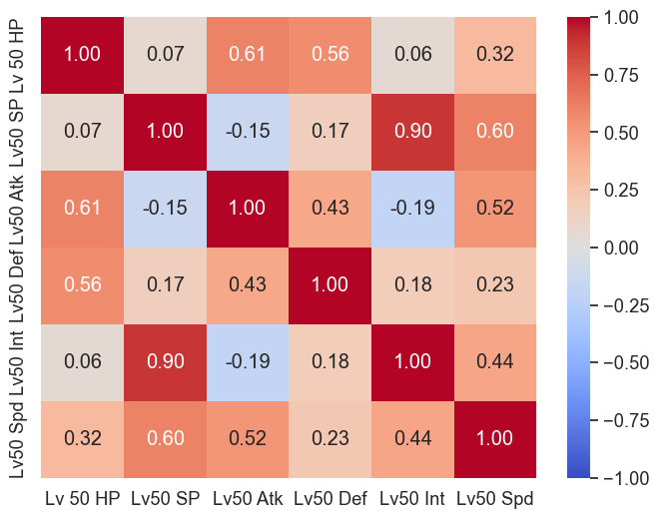

Digimon with Maximum and Minimum Stats at Level 50
Created a horizontal bar plot to visually compare the highest and lowest performing Digimon for each stat.
Each bar is labeled with the Digimon name and attribute, making it easy to interpret extremes across stats like HP, SP, Attack, etc.

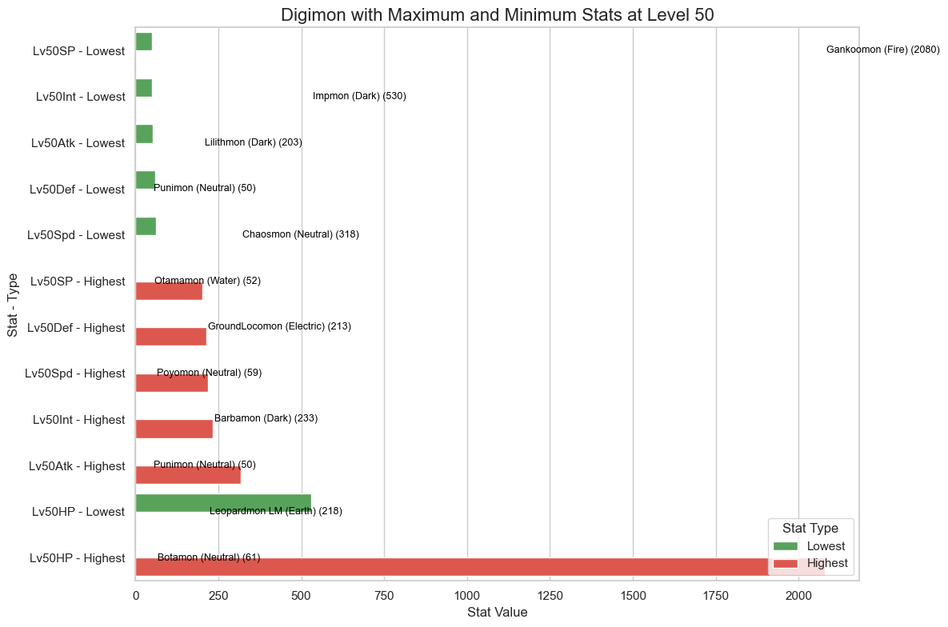

Dataset Distribution Visualizations
Visualized distributions of key numeric features across datasets

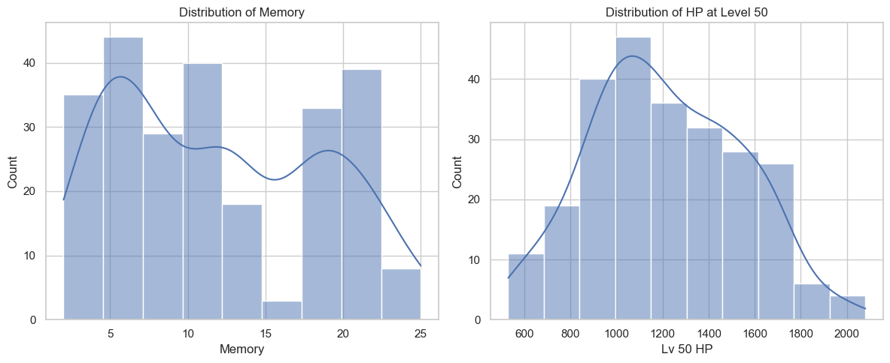
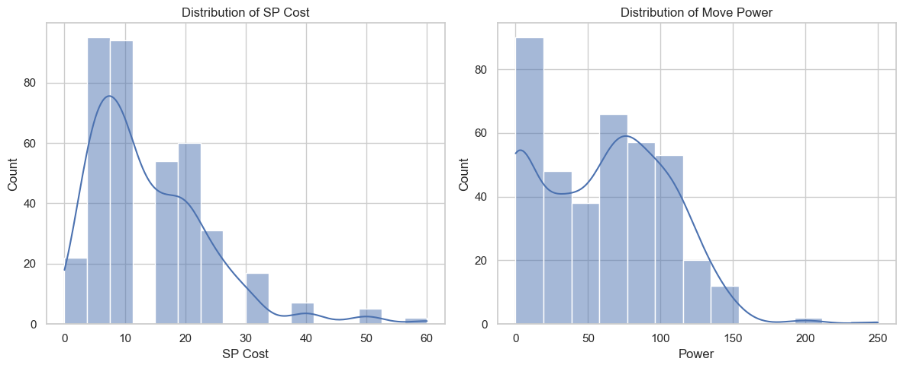

Top 10 Digimon by Total Stats
- Combined 6 key stats to compute overall strength
- Visualized top performers using a horizontal bar chart
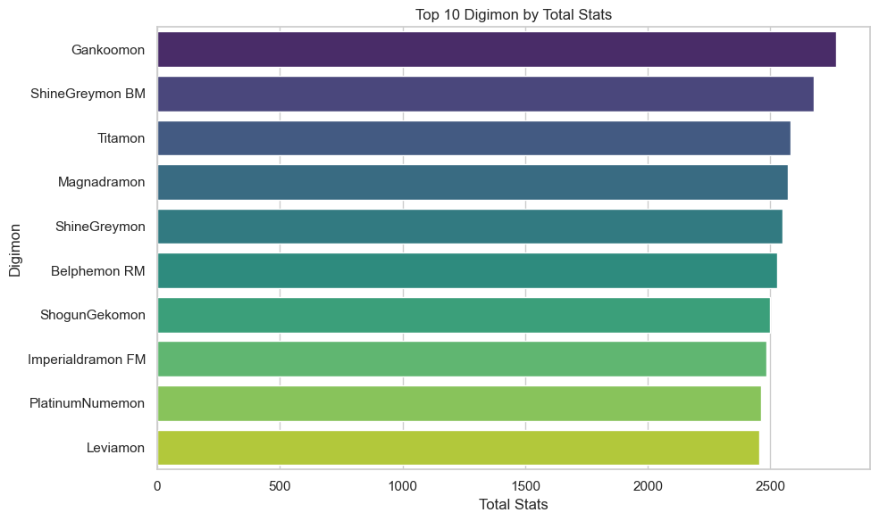

Top 10 Attackers & 🛡️ Top 10 Defenders
- Left: Digimon with highest Attack at level 50
- Right: Digimon with highest Defense at level 50
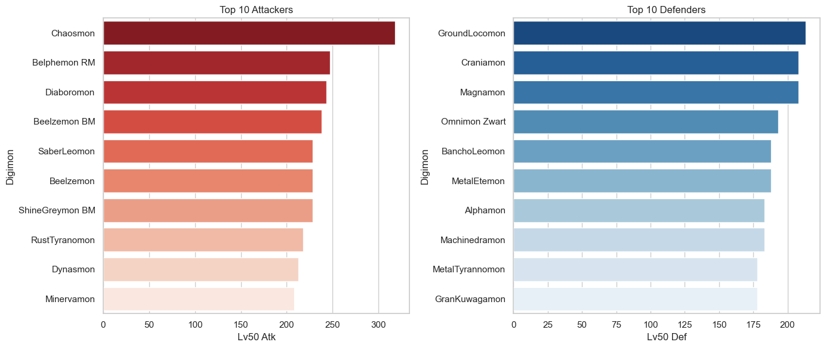

Distribution of Digimon Types & Attributes
- Bar plots showing frequency of each Type and Attribute
- Helps understand diversity in Digimon characteristics
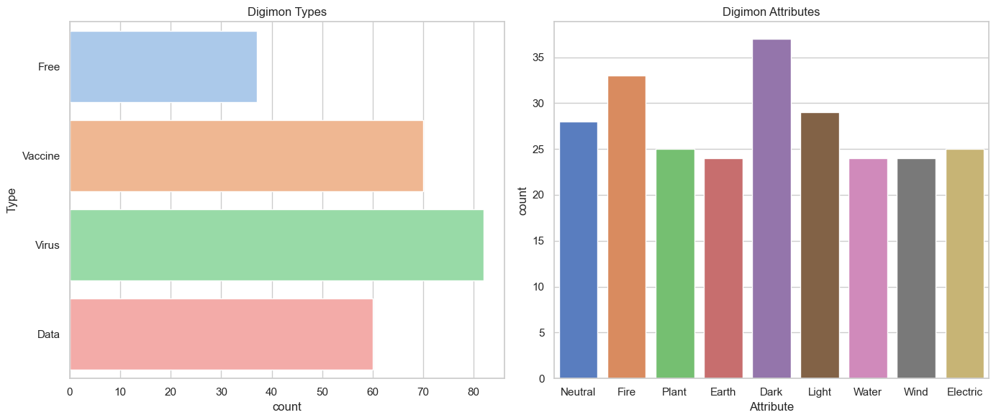

Visualizing the Blueprint for the Ultimate Digimon Team
Use these insights to craft a balanced, strategic team built for any battle.
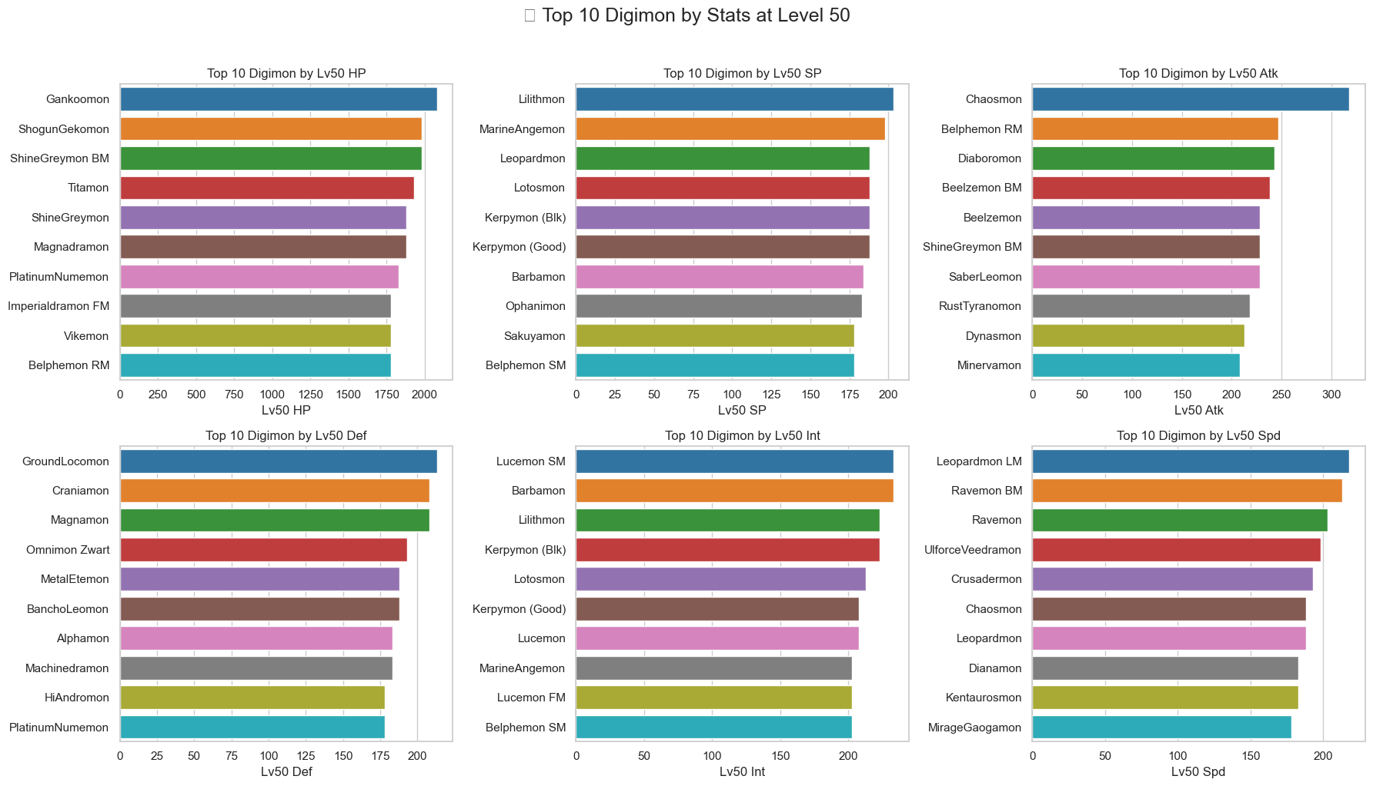

Best Team Analysis – Digimon Selection
To identify the best possible team of Digimon, we analysed the top 10 performers across six critical Level 50 stat categories:
- HP (Hit Points)
- SP (Skill Points)
- Atk (Attack)
- Def (Defense)
- Int (Intelligence)
- Spd (Speed)
The objective was to form a well-balanced and versatile team capable of excelling in multiple battle scenarios, including offense, Défense, and support roles.

Final Team Selection
Based on the statistical charts and performance analysis, the following Digimon were selected for their exceptional strengths in key areas:

1. Gankoomon
- Role: Tank
- Strength: Possesses the highest HP among all Digimon, making it ideal for absorbing damage and protecting teammates.

2. Lilithmon
- Role: Support / Magic DPS
- Strength: Highest SP, enabling frequent usage of powerful skills and support abilities.

3. Chaosmon
- Role: Physical DPS
- Strength: Top-ranked in Attack, serving as the primary physical damage dealer on the team.

4. GroundLocomon
- Role: Physical Defender
- Strength: Possesses the highest Defense, effectively reducing incoming physical damage from enemies.

5. Lucemon SM
- Role: Special Attacker
- Strength: Highest Intelligence, making it ideal for dealing heavy magical damage.

Conclusion
This team represents a balanced composition of tanking, physical and magical damage, and support abilities. Each Digimon was carefully selected based on statistical dominance in their respective roles, making this line-up highly competitive across a range of battle conditions.

Final Conclusion
Through comprehensive data exploration, integration, cleaning, and visualization, this project successfully analysed the Digimon dataset to uncover strategic insights for team composition and game performance optimization.
Key achievements of this analysis include:
- Data Quality Assurance: All three datasets—Digimon stats, moves, and support skills—were found to be complete and duplicate-free, ensuring high reliability in analysis.
- Statistical Insights: The analysis revealed significant variations across Digimon types, attributes, and evolution stages. Magic-oriented Digimon showed strong correlations between SP and INT, while physical attackers were best identified by high ATK and SPD combinations.
- Strategic Visualizations: Scatter plots, box plots, bar graphs, and heatmaps were utilized to visualize relationships and distributions, helping to pinpoint outliers, extremes, and balanced options for team formation.
- Best Team Selection: A top-tier team of five Digimon was assembled based on statistical dominance across six core performance categories. This team—featuring Gankoomon, Lilithmon, Chaosmon, GroundLocomon, and Lucemon SM—balances tanking, support, physical DPS, defence, and magical offense, making it well-equipped for various battle scenarios.

✅ Final Takeaway
This project demonstrates the powerful role of data science and visualization in gaming strategy. By applying structured analysis to raw Digimon data, we not only enhanced understanding of in-game mechanics but also delivered an evidence-based blueprint for building the ultimate competitive team.

